Project Plan

Team Flight

1. Purpose

The purpose of this project is to create a 3D drone flight simulator application for Windows and Android operating systems. We plan to extend the simulator to control a physical drone.

2. Period of work

Spring 2015 semester. From January to May.

3. Statement of Work

|  |  |  |  |  |
| --- | --- | --- | --- | --- |
| Statement of Work | | | | |
| Task | | Description | Assigned Team | |
| Software Team | Hardware Team |
| A | Video Streaming API | API to receive video from drone in-flight |  |  |
| B | Drone Control API | API to send flight control signals to the drone |  |  |
| C | Hardware Input Class | Sends control signals to physical drone |  |  |
| D | Software Input Class | Sends control signals to simulated drone |  |  |
| E | Combined Input Class | Combined input to simulation or hardware |  |  |
| F | 3D Drone Simulator | Basic 3D flight simulator in first-person view |  |  |
| G | Art Assets | All 3D models, 2D art, and backgrounds |  |  |
| H | User Interfaces | All menu screens and UI overlays |  |  |
| I | Desktop Application | Drone flight Simulator, no hardware capability |  |  |
| J | Game Elements | Missions, Tutorials, Challenges |  |  |
| K | Finished Software | Allows Simulation or physical drone flight |  |  |

4. Resource List

|  |  |  |
| --- | --- | --- |
| Resource | Description | Availability |
| 1 Parrot AR Drone | Purchased by UHCL | 90% |
| 3 to 5 Desktop computers | Owned by team members and UHCL | 100% |
| 1 to 2 Android devices | Owned by team members | 100% |
| 1 to 2 XBOX 360 controllers | 1 owned by team member | 70% |
| Software | Java IDE, 2D/3D art creation software | 80% |

5. Work Breakdown Structure

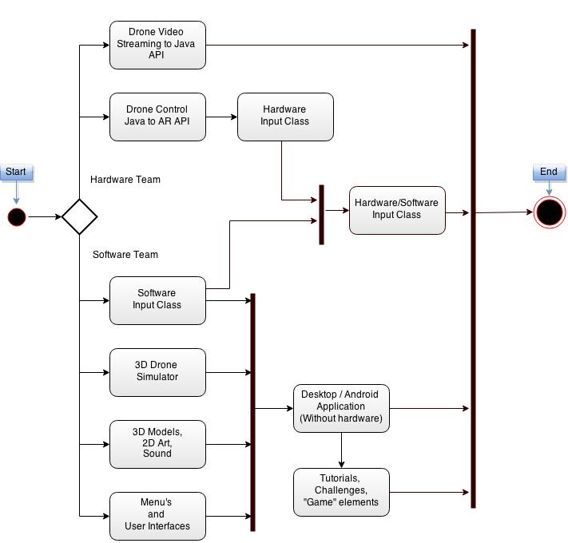

6. Project Schedule

|  |  |  |  |  |
| --- | --- | --- | --- | --- |
| Schedule | | | | |
|  | Task | Pre-requisites | Time Estimate | Criticality |
| A | Video Streaming API | None | 2 weeks | 70% |
| B | Drone Control API | None | 2 weeks | 90% |
| C | Hardware Input Class | B | 1 week | 90% |
| D | Software Input Class | None | 1 week | 100% |
| E | Combined Input Class | C, D | 1 week | 95% |
| F | 3D Drone Simulator | None | 4 weeks | 100% |
| G | Art Assets | None | 2 weeks | 80% |
| H | User Interfaces | None | 2 weeks | 80% |
| I | Desktop Application | D, F, G, H | 3 weeks | 100% |
| J | Game elements | I | 2 weeks | 50% |
|  | Finished Software | All | 1 week |  |

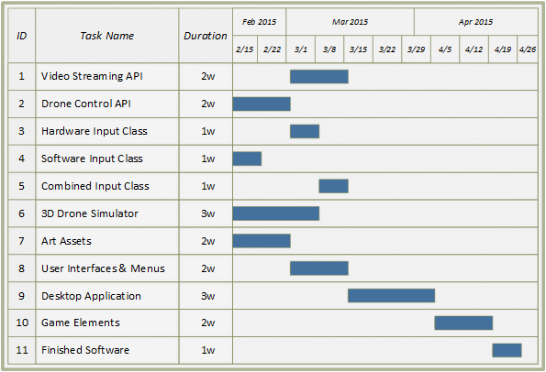

7. Risk Plan

* Damage or loss of test drone
  + Try to repair drone
  + Try to procure a replacement drone
  + Exclude hardware development (Task A,B,C,E) and increase software features
* Legal repercussions regarding drone flight
  + If drone flight rules are changed to the point we can’t fly the drone we will exclude hardware development (Task A,B,C,E) and increase software features
* Complexity of project in regards to tying together the software and hardware platforms
  + Re-evaluate the feature list and cut features which can’t be implemented in our time table
* Interference with wireless signals and communication problems between software and drone
  + Attempt to relocate drone or bypass interference
  + Research better wireless communication protocols (IR, RC, blue tooth)